Georgia Association for Industrial-Organizational Psychology (GAIOP)
2019 Annual Report

Message From the President: John Morrison, Ph.D.
2019 was a year of firsts for GAIOP!
Last year took GAIOP in new directions leading to several firsts for the organization. Most notably, three new members joined the Board. I would like to acknowledge their contributions.
MaryAnn Jerrum, MA, is the new Membership Vice President. MaryAnn brings a great deal of energy and enthusiasm to the Board, and continues the association’s outreach efforts to students in regional I-O programs. She has explored and implemented various member recognition and appreciation initiatives, and she assumed responsibility for coordinating GAIOP’s Social Events. When needed, MaryAnn has rolled up her sleeves and done whatever is asked to make sure the workshops run smoothly.
Joy McCarthy, PhD, is the new Programs Vice President. Doing a job once held by two people, she has fostered excellent relationships with our important Division 14 contacts and our generous local benefactors, the organizations who have graciously donated their facilities for GAIOP workshops. In concert with a hard-working Programs Committee, Joy impressively developed several high-level topics into full-fledged workshops and, in other cases, oversaw the entire process from beginning to end. In every case, she maintained the high standards for workshop content and delivery that members have come to expect.
Amy Stewart, PhD, is the new Secretary-Treasurer. Amy has drawn on her unique accounting skills to standardize and greatly streamline the association’s financial tracking and reporting processes. She successfully developed new expense payment and reimbursement procedures that have enabled all Board members to better manage their responsibilities. Amy conducted benchmarking research on how other non-profit organizations manage their budgets, particularly with regard to reserve funds. She also pitched in and took a hands on approach to workshop delivery.
Andy Neiner, PhD, Communications Vice President. Andy continued to show dedication to the local I-O community by agreeing to continue serving on the 2019-20 Board. In this capacity, he diligently maintains the association’s website and ensures that it provides timely information to members and other interested parties. He has also served as an active conduit of information to student and professional members regarding vital workshop information and registration procedures, and posting job and internship opportunities. Through summaries and photos that capture the moment, he helps showcase the association’s events on the website as well.
It was a pleasure serving with this team in 2019 and it continues to be so into 2020. The year would not have gone as well as it did without you and, as I already mentioned, several GAIOP firsts were achieved, including:
- Delivery of six three-hour workshops. This is something the association has aspired to do for a number of years and the 2019 team finally pulled it off.
- Two post-workshop Social Events were held at locations within easy walking distance from the workshop venues. The Social Events, popular ways for GAIOP to give back to its members, were well attended and enjoyed by all.
- Workshops were held at three separate venues for the first time with the help of Friends of GAIOP. Emory University and Novelis provided facilities free of charge on the east side and in Buckhead, respectively. SunTrust made it possible for GAIOP to host its first downtown Atlanta workshop.
- Due to the generosity of Friends of GAIOP and our member volunteers, we have effectively managed costs and built a secure financial reserve. Consequently, membership dues and workshop fees for 2020 have remained at 2019 levels.
If you have questions about that or any of the information I have shared with you, please do not hesitate to contact Andy communications@gaiop.org or me president@gaiop.org.
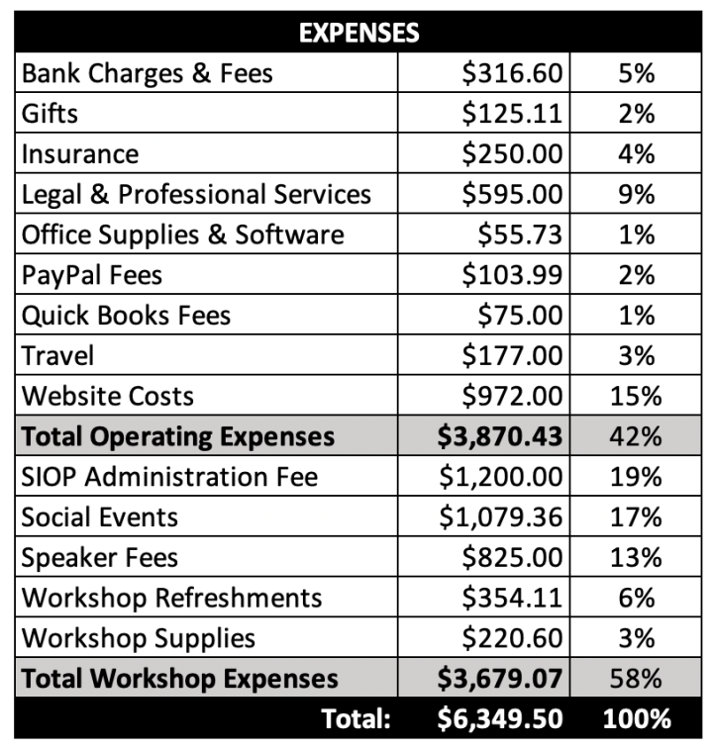
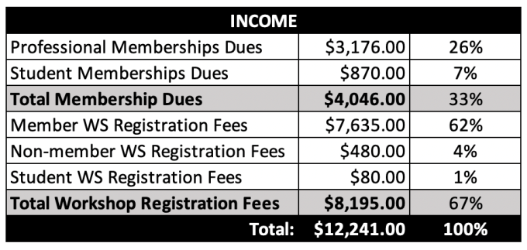
2019 Financial Summary
